Title of Case Study:
Safer Way to School

Country:
Slovenia

Implementation Organization:
Pilot project for Master’s Thesis, later adopted by Slovenian Infrastructure Agency and Municipalities for implementation on state and municipality roads

Subject – Please identify what subject/topic the case study covers.
In Slovenia, there is not yet a harmonized strategy and with that directive or guidance how to deal with school paths and vicinity of schools alongside roads (consequence of poor spatial planning and land use / urbanism), so Pilot project aim was to make and to introduce low cost solution, without construction intervention (prompt measures), using good practice and Human Factors knowledge in Road Design, and with that improve road safety from infrastructure pillar of UN Decade of Action for Road Safety. The aim of the project was to implement safe(er) School and Kindergarten area on municipality road by introducing Human Factors in to the road (re)design. The pilot project could be used to learn (find potential defectiveness and find improvements), for further “best practice” implementations on Slovenian roads and background for legislative part (1st pillar) and potential guidance how to deal with those kind of problems (linear settlements and schools alongside roads).
Location, suitable for pilot project, was defined together with municipality of Žalec, taking into the consideration road safety issues around schools and the location of schools. As majority of schools are situated in urban areas with traffic calming measures and reduced speed limit “Zone 30”, we defined School and Kindergarten Trje, to be most appropriate for the project, as it is outside urban area, with set up speed limit of 50 km/h.
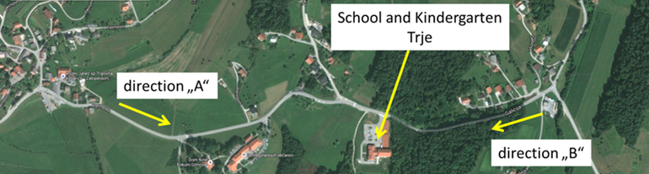
Figure 1: Location of School and Kindergarten alongside the road and direction of travel

When driving on the road (in the vicinity of school and kindergarten Trje), driver does not get proper information that School and Kindergarten is nearby and with that also children as vulnerable road users (VRU) to be present on the road. Drivers in transit do not expect that School and Kindergarten will be situated outside the town, while ones who are familiar with the location of School and Kindergarten (the locals) pay a little attention to it, as they drive by daily in automated driving mode (daydreaming etc.). So the existing road design is not very self-explaining. We could say that road does not speak to the drivers and therefore they are not attentive to potential danger – children on the road.

Project Description and Summary - Please provide a brief description of the project, effort, or initiative undertaken. What was the objective of the project and when was it implemented?
First information was gathered from school, where pupils actually walk. After receiving all the information, designing of the solution took place in the way, that road will “talk to drivers” by its design – “be aware of children”. Information signs and markings were designed, in user friendly way, to talk to drivers and stimulating them to be more attentive of children on the road and at the same time encourage them to drive with more caution.
In close vicinity of School and Kindergarten junction, where there are also bus-stops and a pedestrian crossing, special totems were set up and colourful bollards.
Traffic signage, urban equipment and markings were carefully designed and put into place considering the road alignment and roadside environment.
All equipment (especially bollards) was carefully chosen so that in the case of impact they do not pose additional threat to road users. Passive safety is also important when designing this kind of safety solutions.
In addition self-explaining information signs were set up at the beginning from each direction of travel towards the School and Kindergarten. From information signs, all the way to School and Kindergarten where pupils walk to and from School, and kindergarten children take their daily stroll, colourful circles, with additional anti-skid elements, were marked on the pavement, as shown in figures 3 and 5 below. Circles were separated apart (raster / distance between them), so that children could not play on the pavement, by jumping from one circle to another.

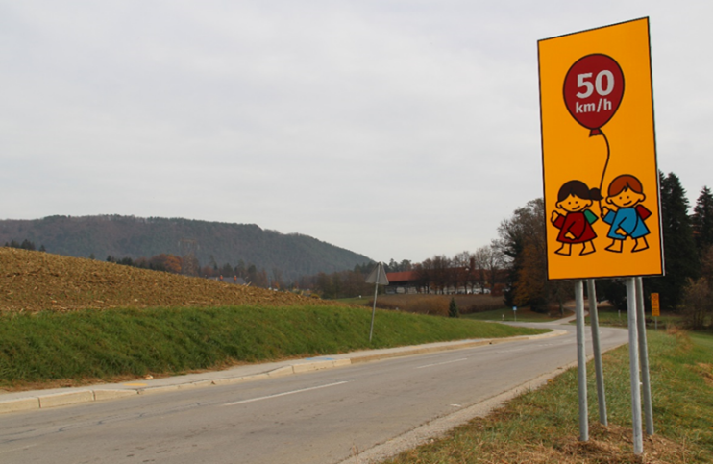
Figure 2: Information signs

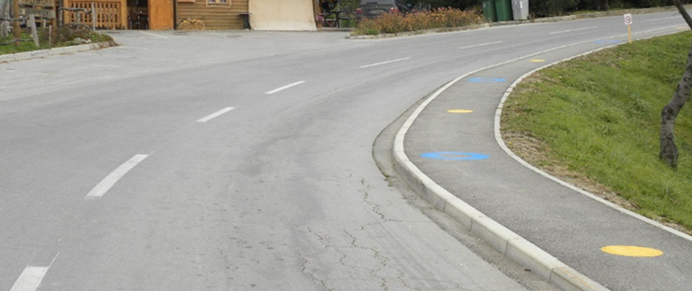
Figure 3: Pavement markings (blue and yellow circles)

In near vicinity of school (near pedestrian crossing, bus-stops and junction to school), totems were set up, with colourful bollards as shown in figure 4. Also red colour surfaces before the junction were applied and pedestrian crossing was made on blue contrast surface (figure 5 and 6). Existing traffic signs were replaced with new ones and repositioned on more suitable locations. Also some traffic signs (for pedestrian crossing and bus-stop) were made with yellow fluorescent background, to be more conspicuous.
.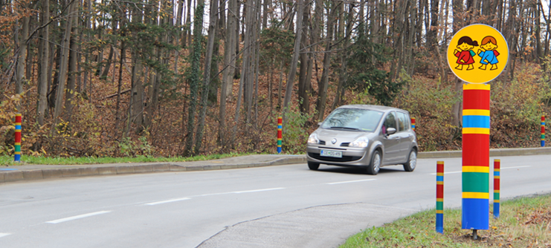
Figure 4: Totem with colourful bollards

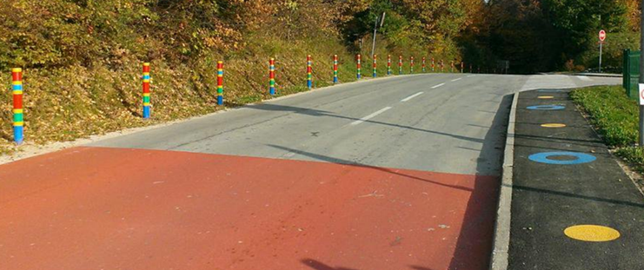
Figure 5: Colourful bollards, red surface before the school junction with colourful circles on the pavement

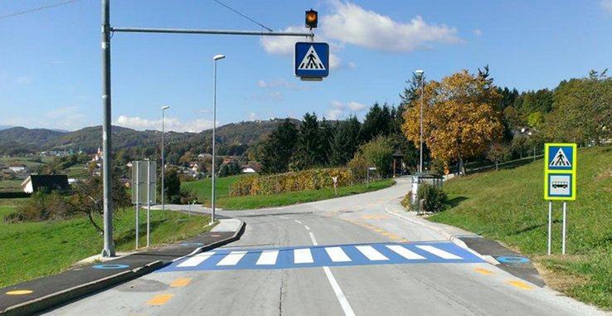
Figure 6: Pedestrian crossing on blue contrast and new traffic sign

The overall costs for the pilot project were hi, as a lot of man hours went in (brain storming and finding right solutions, including some tests before implementation, work and material), so overall costs for designing and implementing the projects are estimated on 37.582,71 EUR.

Key results/accomplishments - What key results and accomplishments were achieved or what changes resulted?
The design was very well accepted among children, parents, teachers, local community and drivers. The idea behind the design and its purpose was to alert drivers, to properly stimulate them to be more attentive for children presence and to reduce speed.
Speed monitoring (before/after) was also carried out, with Traffic data collection of traffic volume and speeds (ViaCount II). I monitored speed before the project:
• June ’15 (during School),
• July ’15 (School-brake),
• September ‘15 (beginning of School),
and after the project implementation:
• December ’15 (during School).
Monitoring was done in similar weather and road conditions, so the weather and the road surface did not affect the driving speed.

Graph 1: Speed monitoring (before/after)
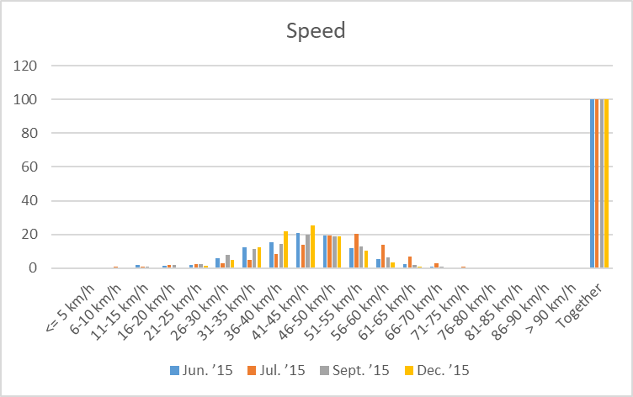

Graph 2: Speed distribution (before/after)
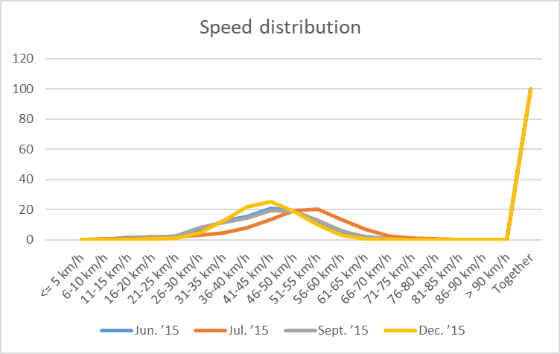

When analysing the speeds, we came to the conclusion that after the project implementation, speeds were lower and also extremes, those who were driving way over the speed limit, has been reduced. Also those who were driving before within the speed limit (50 km/h), they drove between 46 km/h and 50 km/h and now, after the project implementation, there speeds come down between 40 km/h and 45 km/h. It also can be seen that the curve of the normal distribution (Gaussian distribution), in graph 2, has moved to the left in December ’15 (after the project design was implemented and in practice for over a month).
Alongside the speed monitoring the survey was carried out, with a desire to get answers if drivers understood the colourful road design, its purpose, and how do they re-act upon that. We wanted to know if design is enough “Self-explaining”, do drivers know, that the School is near and therefore presence of children, and do drivers become more attentive, more alert, for children presence.
The survey was carried out in the local community and 131 replies came back.
According to Slovenian regulations, the driver beginner (young driver) is driver until the age of 21 years or driver who has driving license up to 2 years, for older drivers are considered those of age more than 64 years, and in between those two categories are “other” drivers.

Graph 3: Question about “Self-Explanatory” road design
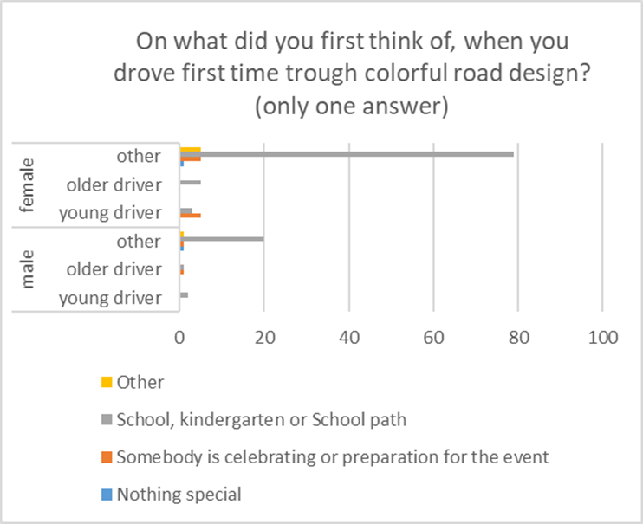

Looking at answers from graph 3, the colourful road design is understandable, as drivers did understand the meaning of the design and that is about School, Kindergarten and School path – presence of children. So, self-explanatory of the design was confirmed.

Graph 4: Question regarding drivers’ re-action
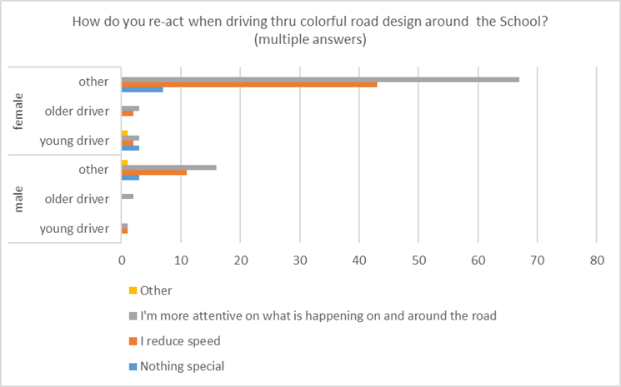

From graph 4 answers, we can see that self-explanatory road design has a positive effect on drivers’ behaviour. They tend to be more attentive, more alert, of what is happening on or beside the road – more watchful for children and they slow down, as was also confirmed by speed monitoring.

Graph 5: Question about likability of the colourful design
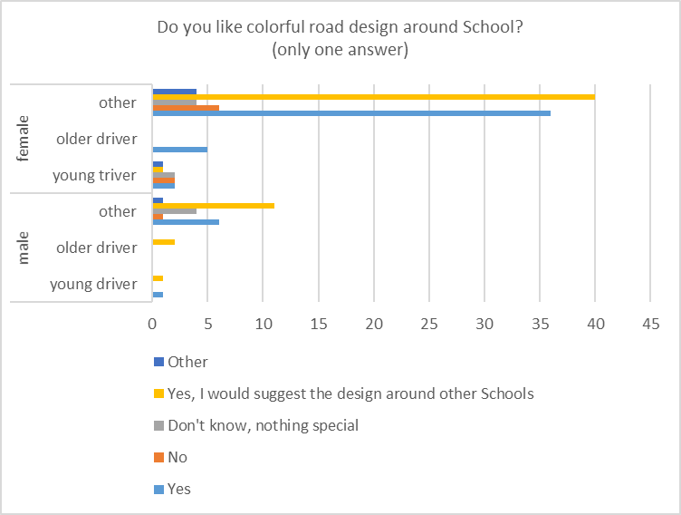

Again, answers about the likability, acceptance, of the colourful road design, in graph 5, are positive. Drivers do like and accept it, and they recommend it, for further usage around vicinity of other Schools and Kindergartens.
For conclusion, we can fairly say that the project is a success and has beneficial results on driver behaviour – speed and attention.
By thoughtful incorporation of Human Factors knowledge in to the road design, we can enhance Road Safety, and at the same time tackle nowadays ever-growing problem on drivers’ Distraction and Fatigue.

Policies – Were new policies put in place? If yes, what were these policies?
Yes. Slovenian Infrastructure Agency recognised the solution as effective considering problems of inadequate spatial planning and urbanism and ever-growing problems in traffic regarding drivers’ Distraction and Fatigue. So the design was adopted by the Agency and is starting for brother implementation on state roads, tackling speed management and attention of drivers while driving thru School areas and where School Children walk. Also promotion campaign is scheduled thru this year for awareness and education purposes.
Also in Roads Act (when it was supplemented) the act covering innovation / pilot project was changed in a way that pilot projects (good practice) can be easily implemented on state roads and consequently other regulations covering roads.

Barriers/Obstacles – What barriers or obstacles were overcome in the effort?
Considering the legislation, the road re-design could not be drastically changed, as we did not want to make the solution legislative litigable, and also some budged restrictions had to be considered as pilot project was supported by the companies (donors), who decided to do the work “pro-bono”.
The main problem was, finding the right products for the solution. As this was a pilot project, a lot of improvising had to be done, to find the right materials and products for the solution. We had to use materials / products that were available to me by the product range of the donors.
Special problem was finding the right materials for totems and bollards as well designing the right dimensions and raster between colourful circles on the pavement.

Lessons learned – What were the key lessons learned? What advice can you offer to others from these lessons?
The most important lesson is: “Where there is a will, there is a way!”, meaning even if there is a legislative barrier, we have an obligation to promote and implement good practice solutions on our roads and even change legislation if needed.
Of course the solutions must be well thought thru with understanding of Human Factors in Road Design and after implementation also monitored and evaluated.

Contact – Who can be contacted for more information?
Uroš Brumec, Slovenian Infrastructure Agency (uros.brumec@gov.si)
Twitter: https://twitter.com/_Safe_to_School
LinkedIn: https://lnkd.in/Y5sZqR
Youtube: https://www.youtube.com/channel/UC9DtYTYweWw4oWsNO8wQq1g

Photos – If available, please provide high resolution photos to demonstrate the case study. If more than one, please upload a zip file.

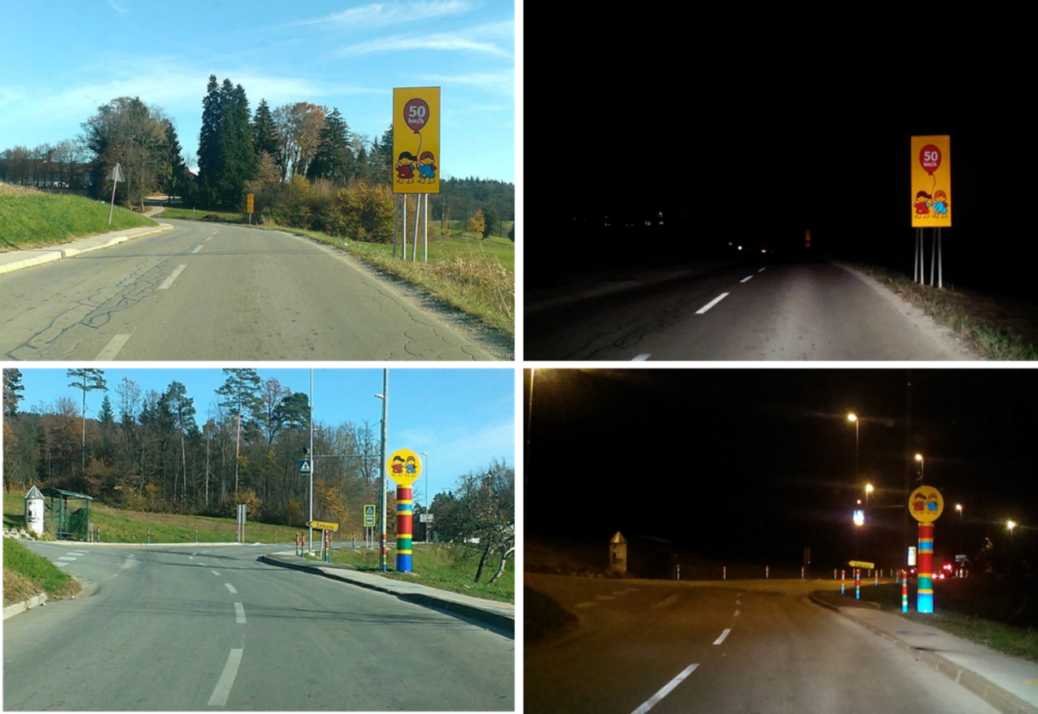
Day / night visibility of information sign, totem and bollards

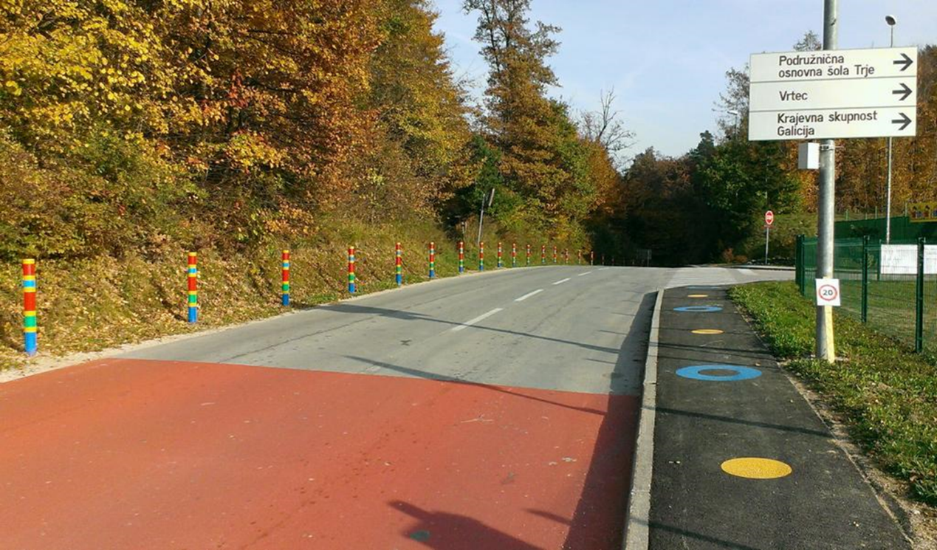
Colourful road environment near the junction to School

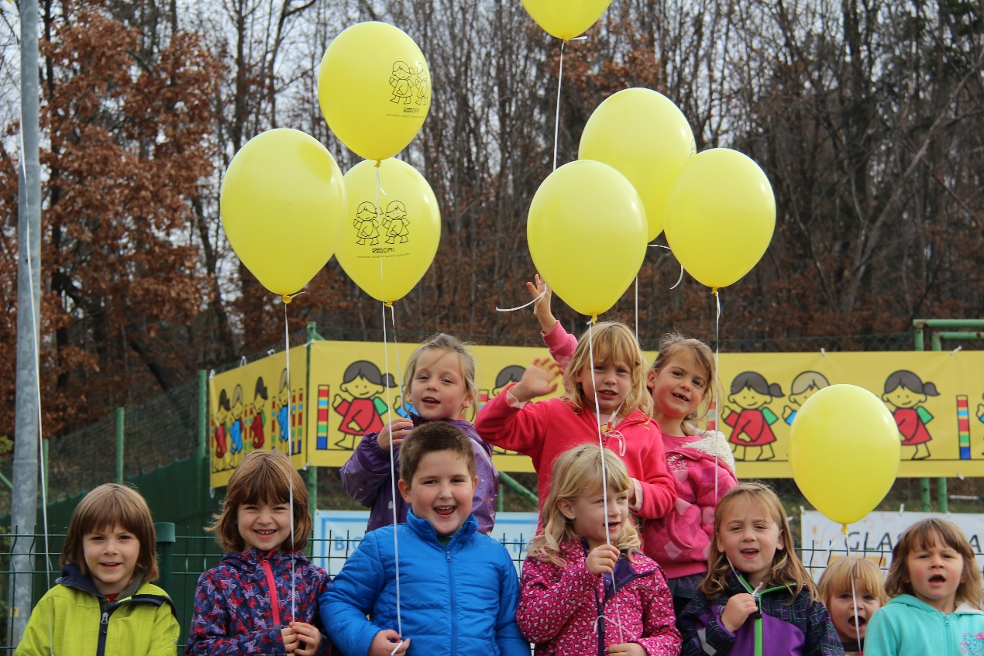
Official opening day of pilot project

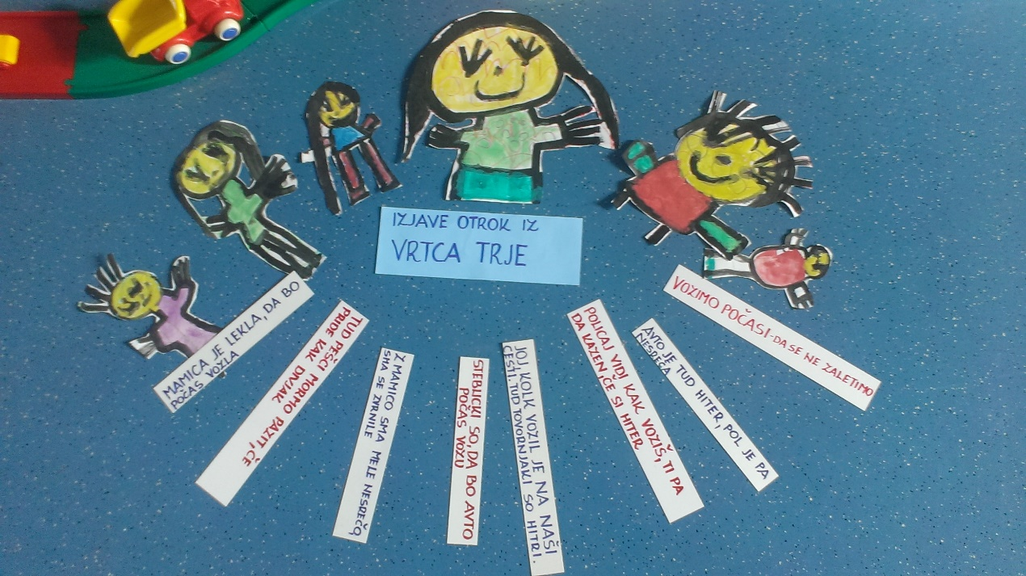
Drawings from kindergarten children and their and theirs parents statements (like: “My mommy said, she will drive more slowly now”, “We as pedestrians must watch out as well, if some savage driver drives by”, “Bollards are here, so that the car will drive slowly” …)
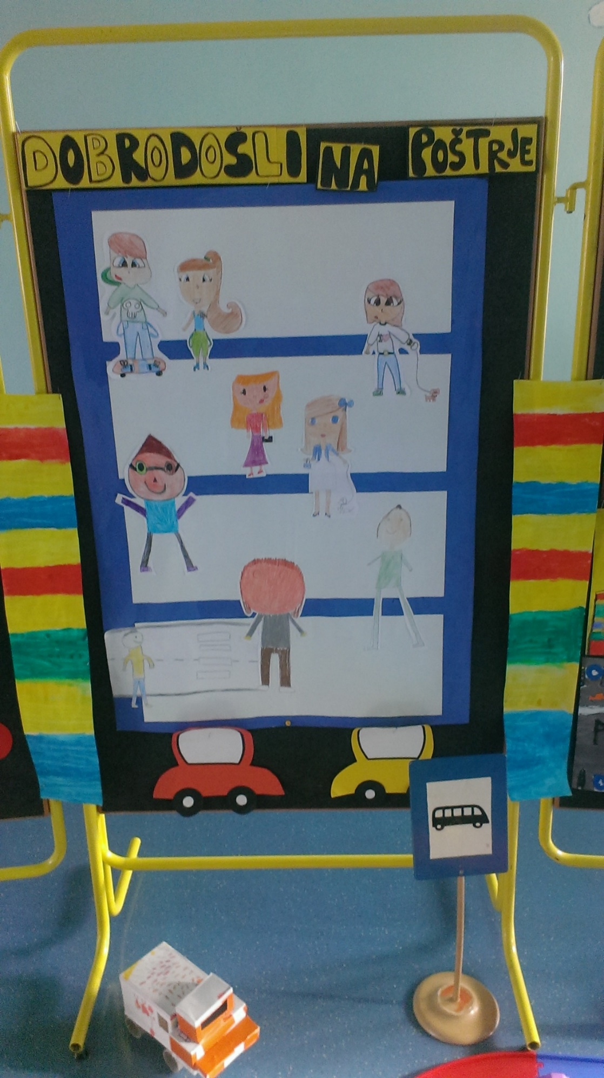
Drawings from school children

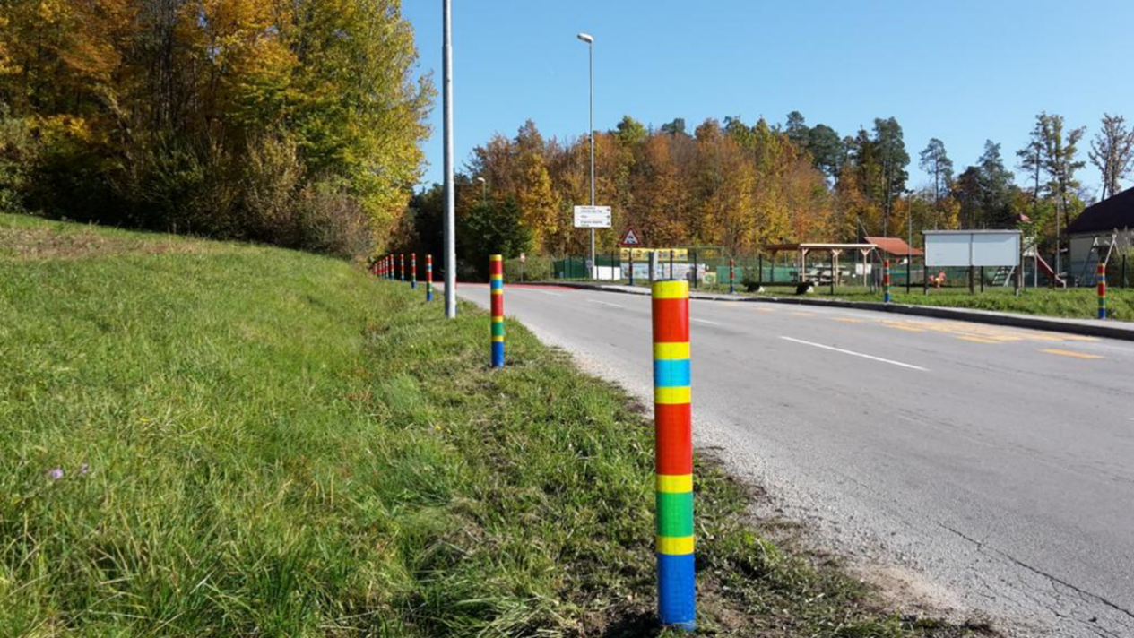
Colourful bollards with School and Kindergarten behind

Case study Priority (1 to 10)
9

Please propose the chapter of the RSM where you imagine this Case Study is best fit (from 1 to 12)
8

Please describe where, in the chapter, your case study is best fit.
Paragraph 8.2, subparagraph “COMMUNICATION WITH ROAD USERS”

References:
Brumec, U., Hrabar, V., N. (2016). How can we enhance the safety of school children with usage of human factor knowladge in road design. Dostopno na: http://www.nc-piarc.si/dokumenti/gradivo_clanov/Brumec_Referat_BiH_2016.pdf

Brumec, U. (2016). Projektna naloga. Varnost šolarjev pred šolo in na poti v šolo – ureditev prometne infrastrukture z upoštevanjem človeškega dejavnika. Dostopno na: http://www.nc-piarc.si/dokumenti/gradivo_clanov/Projektna_naloga_Brumec_2016.pdf

Centrum voor Regelgeving en Onderzoek in de Grond-, Water- en Wegenbouw en de Verkeerstechniek – CROW. (2005). De goede 30-km/h-wijk maak je samen! Dostopno na: https://www.crow.nl/publicaties/de-goede-30-km-h-wijk-maak-je-samen!?page=49&searchsort=date&pagesize=10

Institut Belge pour la Sécurité Routière – IBSR. (2002). 30 km/h aux abords des écoles. Dostopno na: http://webshop.ibsr.be/frontend/files/products/pdf/4c475dd66679257bb545cb3dc7171c66/30-abords-ecole.pdf

Stadsregio Amsterdam. (2012). Leidraad inrichting veilige schoolomgeving. Dostopno na: https://tools.kenniscentrumsport.nl/schoolzone/wp-content/uploads/sites/13/leidraad-schoolzones.pdf

World Road Association – PIARC. (2008). Human factors guidelines for safer road infrastructure. Dostopno na: https://www.piarc.org/en/order-library/6159-en-Human%20factors%20guidelines%20for%20safer%20road%20infrastructure.htm
World Road Association – PIARC. (2012). Human factors in road design. Review of design standards in nine countries. Dostopno na: https://www.piarc.org/en/order-library/19929-en-Human%20factors%20in%20road%20design.%20Review%20of%20design%20standards%20in%20nine%20countries.htm

World Road Association – PIARC. (2016). Human factors guidelines for a safer man-road interface. Dostopno na: https://www.piarc.org/en/order-library/25370-en-Human%20factors%20guidelines%20for%20a%20safer%20man-road%20interface.htm

Please write here your E.mail:

uros.brumec@gov.si

