**“Safe pedestrian: common responsibility”**

Country/Region/City/Company: Poland, Malopolska, Małopolska Wojewódzka Rada Bezpieczeństwa

Ruchu Drogowego (Malopolska Regional Road Safety Council) : www.brd.malopolska.pl

Start Date and duration : 01. 2019- 05. 2022

The project “ Safe pedestrian: common responsibility” aims at pedestrians’ safety in Malopolska Region. It is a clear response for the main road safety problems in the region referred in clear statistics – the pedestrians safety.

**Storyline**

**Genesis**

In 2015-2017, from the initiative of Traffic Department of Regional Police Headquarters in Cracow (Wydział Ruchu Drogowego KWP w Krakowie), a complex check of illumination and check of road marking of pedestrian crossings was implemented in whole region of Malopolska. The control revealed the below mentioned abnormalities:

1. National roads: 479, illumination irregularities: 270 (56% of all)
2. Provincial roads: 588, illumination irregularities: 393 (66% of all)
3. County roads: 1079, illumination irregularities: 560 (51% of all)

The control allowed to diagnose irregularities in infrastructure in the most dangerous places for pedestrians. What was checked was: illumination - if existed, if wrong illumination was applied, road safety facilities, but also necessity of existence of pedestrian crossings (some of them were unnecessary, not in use). In 2017, after second verification, the problem appeared to be bigger and the number of irregularities increased.

Who would cover the costs? The financing was supposed to be covered by **road administrator or local government.** This was a real obstacle as none of them wanted to cover the costs, even with police recommendations for urgent improvements. The problem was identified but there was not any program nor economical support that would solve it. The road administrator assumed that improvement of the illumination was in competences of local government, and local government assumed the additional illumination was in gesture of road administrator as it is road safety facility. The circle was closed and it looked like no solution was supposed to be found.

**2018: Forming the team**

The problem of pedestrians’ safety, although already existed before, was focused at the end of 2018. The impulse, after the control of the results of regional Police Headquartes, came from the Deputy Marshal of Malopolska, Mr. Łukasz Smółka. It is important here to see how the structure of road safety works in Poland. The road safety management has one common Road Safety Council (National Road Safety Council) based in Warsaw, depending on Ministry of Infrastructure. In regions - regional Councils. The councils are located in local Traffic Centers responsible for exams for driving licenses. The councils in regions are formed by local representatives of institutions and organizations involved in road safety and are nominated by local Marshal. Normally they have no separate budgets and their role is more based on advice and opinion. Apart of this, there are other institutions responsible for road safety, but they directly report to correspondent Ministries.

In case of Malopolska region, a significant decision was made at the end of 2018. The decision of Mr. Łukasz Smółka, Deputy Marshal of Malopolska was to **activate the Malopolska regional council and transform it from advice unit**, **into active unit that would react to main problems and implement road safety programs**. The idea was to give to the council more role in **decision-making process within road safety in Malopolska**. Having that in mind, after forming the local team dedicated to road safety, a common budget was created to cover the basic needs of the council: prevention activities of the members and common joined activities controlled and organized by one of the leaders of the council. This would give the members the possibility to lead prevention in their surroundings, but also to unite projects under one voice and leadership, giving them more strength and influence on the implementation. None of this would be possible without nor political will, nor shared responsibility. The Regional Malopolska Council, composed of 30 organizations and institutions (official institutions and non-profit organizations, media) has been settled for new.

**2018: Identification of main problems**

From the beginning it was clear, that any actions that would be planned, shall be based on facts, statistics, scientific data and a solid base of identification of real problem. In 2018 the Council had at disposal 3 types of data:

1. Road Safety Statistics.
2. Diagnose from Police Headquarters of irregularities of pedestrian crossing infrastructure.
3. Scientific indications (National Road Safety Council and Motor Transport Institute) how to implement safe and effective illumination of pedestrian crossings.

Road Safety Statistics

Statistics of road crashes with participation of pedestrians in years 2014-2018 in Malopolska region



Number of mortal victims – pedestrians

Percentage of participation of pedestrians among mortal victims

The analysis of the causes of road crashes caused by drivers towards pedestrians in 2018 confirms that the greatest risk to pedestrian traffic participants occurred in the area of ​​pedestrian crossings.

Location of road crashes with participation of pedestrians in 2018

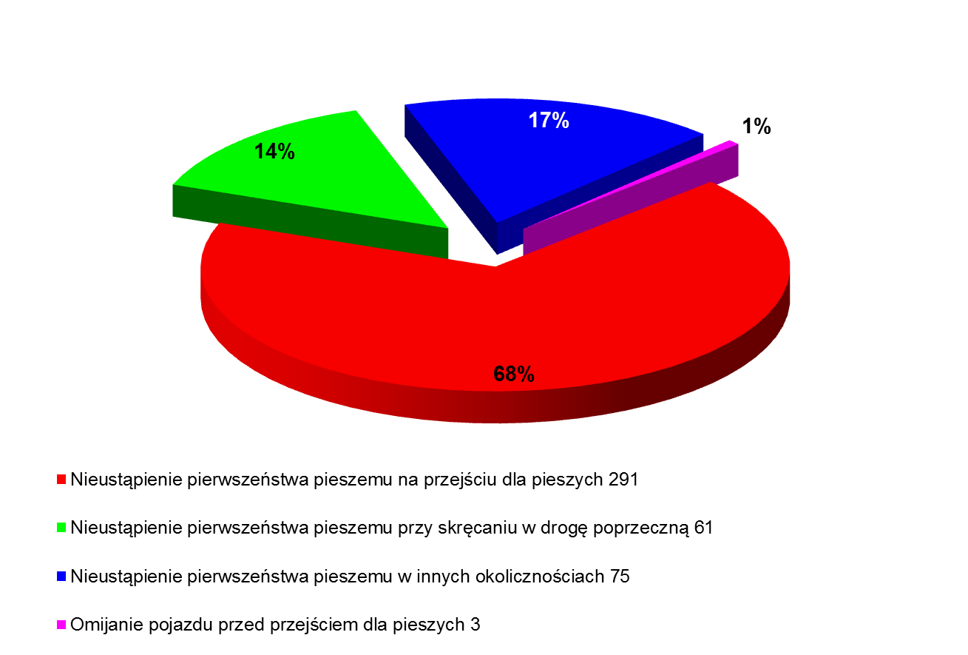

Failure to give way to pedestrians at a pedestrian crossing: 291

Failure to give way to pedestrians at turning into a transverse road: 61

Failure to give way to pedestrians in other circumstances: 75

Avoiding a vehicle before a pedestrian crossing: 3

Małopolska, 2018

|  |  |  |  |
| --- | --- | --- | --- |
| **Locations of pedestrians traffic** | Crashes | Mortal Victims | Victims |
| **Pedestrian crossing** | **405** | **20** | **394** |
| Crossing | 272 | 12 | 265 |
| Pavement, pedestrian way | 38 | 6 | 31 |
| Shoulder | 10 | 2 | 8 |
| Public Transport Stop | 21 | 0 | 20 |

After deep study of the main road safety problems, main areas for improvement were revealed:

* Very high number of fatal crashes with the participation of pedestrians in the region
* Low visibility of the crossings and pedestrians
* Speeding
* Lack of education: low conscience of the risk and consequences
* Lack of the post- crash response system

On base of the problems, the council prepared the clear response: “Safe pedestrian: common responsibility” project.

**How to solve the problem of financing of illumination of pedestrian crossings? - this was still the main problem.**

In 2018 a very important decision was made by Deputy Marshal, Łukasz Smółka. From its initiative, a program of financing pedestrian crossing was created and founded. The mechanism was: the Marshal Office will cover until 60 % of the costs of the crossing, the rest – 40 % the local government.

This was an ideal solution, common consensus for improvement of road safety and received a great respond from local governments. The program was first aimed at provincial roads but was so well recognized, that the Deputy Marshal broadened it to county roads as well.

**2019: “Safe pedestrian: common responsibility” project implementation.**

The project consisted on 4 pillars:

1. **Illumination of the pedestrians crossings in the region.**

This refers to new illumination or improvement of the illumination that already existed.

In 2019, more than 200 pedestrian crossings on national, provincial, county and municipal roads were illuminated in the Malopolska Voivodeship.

In this area, Malopolska plays a leading role in the country, and the total amount allocated to this aim in 2019 was approx. PLN 7 millions.

In 2020, 122 pedestrian crossings on national and provincial roads were illuminated in Malopolska voivodeship.

*Main actors involved:*

* *Deputy Marshal’s Office of Malopolska Voivodeship (Łukasz Smółka, President of Malopolska Road Safety Council)*

*• Malopolska Provincial Road Safety Council and its members:*

* *Malopolska Regional Police Headquarters in Kraków*
* *Cities and District Police Headquarters*
* *General Directorate for National Roads and Motorways, Kraków*
* *Provincial Road Authority in Kraków,*

*• Commune self-governments of the Małopolskie Voivodeship*

1. **Reduction of speed limits before all pedestrian crossings on 2 types of roads.**

In 2020 , the members of the Council: Regional Headquarters of Police Department, together with Provincial Road Authority in Kraków, following the strategy of the “Safe pedestrian: common responsibility” project, implemented in whole region the reduction of speed limits before all pedestrian crossings on 2 types of roads: regional and national to max. 50 km/h. This implementation was aimed at minimalization of possible risks and crash consequences in the area of pedestrian crossings. The above has been implemented in whole Malopolska.

Main *actors involved:*

*• Malopolska Provincial Road Safety Council and its members:*

* *Malopolska Regional Police Headquarters in Kraków*
* *Cities and District Police Headquarters*
* *General Directorate for National Roads and Motorways, Kraków*
* *Provincial Road Authority in Kraków,*
* *Deputy Marshal’s Office of Malopolska Voivodeship (President of Malopolska Road Safety Council)*

1. **Prevention and education campaigns aimed at pedestrian safety.**

During 2019 and 2020, main projects led by Regional Road Safety Council of Malopolska focused on pedestrians and their visibility were implemented:

a)  Odblaskowa Szkoła (Reflective School),aimed at students from the region – Malopolska Police Regional Quarters as main organizer (Malopolska Council member). Educational project for all primary schools in Malopolska region, leaded in cooperation with Board of Education of the region and other members as partners. It consists mainly on pedestrians’ safety and is addressed to all families. The participants must involve all local society to pedestrian safety starting from providing reflection materials for children, to local events and initiatives as debates, press interviews on safety, painting, knowledge contests and meeting with Seniors to join common road safety goal. Each year approximately 400 schools from Malopolska region take part in the initiative and more than 60.000 reflective materials are spread.

b)  Zapnij Pasy – program in Radio Krakow, Radiostrada, dedicated to road safety. Each year minimum 50 editions of 2 hour long program are created together with Malopolska Road Safety Council that shapes the importance of pedestrian road safety themes. During 2019 and 2020 more than 100 programs were prepared and aimed at auditors of Malopolska.

c) “Jedź bezpiecznie” - road safety tv program in regional TVP Krakow tv (long-term continuous project). Each year minimum 50 editions of 15 minute long program leaded by a top road safety expert are realized and organized by Malopolska Road Safety Council. The programs are showing practical examples from roads of Malopolska of positive and negative behaviours both drivers and pedestrians. The majority of the episodes stress the pedestrian safety problem.

d) Road Show – program based on “peer-to-peer” education methodology, aimed at teenagers who meet directly police, firefighters, doctors, road traffic victims and families of mortal traffic victims who share their experience to prevent and avoid future crashes. The program was focused on pedestrian safety and case studies of pedestrian crashes and gathered in 2019 and 2020 almost 2000 teenagers from Malopolska.

e) “To see and to be seen”- animation annual contest aimed at student of primary and secondary schools in Malopolska, theme: pedestrians. Each year more than 100 animations on pedestrian road safety are presented from the region for the finals.

f) Economic Forum 2019 and 2020- representatives of Malopolska Regional Council with the Marshal of the region, stressing on national and international audience the importance of proper infrastructure of pedestrian crossings, illumination and safety of pedestrians, prevention and post-crash response.

*Main actors involved:*

*Malopolska Provincial Road Safety Council and its members*

*- Malopolska Regional Police Headquarters in Kraków*

*- Board of Education in Cracow*

*-Center of Initiatives for Road Safety*

*-Radio Kraków*

*-Regional TV 3 Kraków*

4. **Post-crash response in the region.**

Zabawa is a small village in Malopolska, where the only monument for road traffic victims in Poland is located. Here, since many years, association Przejście gathers victims and families from all over the country not only to commemorate the victims, but mainly to help those, who survived and grieved families, leading psychological help, support groups and workshops. The association, member of Malopolska Road Safety Council is also planning to create a professional Center for Trauma Recovery, which would include both psychological and physical help, prevention and social help area for victims, that would in a global and complete form fulfill and cover post-crash response help needs for the country.

Thanks to the cooperation with National Road Safety Council and Malopolska Road Safety Council, since 2018, the region has managed to strengthen and implement one, common national celebration of World Day of Remembrance in Zabawa near Tarnów. The celebrations are now officially nationally celebrated in Malopolska in cooperation with FEVR, focusing on the importance of post- crash response.

The support of Malopolska Council and its members within “Safe Pedestrian: common responsibility” project – post -crash response pillar, included also economical help in these years (2018-2020) to broaden the number of workshops / psychological help for the victims and families.

Both of these two actions within the project: symbolic support as unification of celebrations of World Day of Remembrance and strengthening the importance of post-crash response, as well as financing support of psychological help have had a significant impact not only on all the project, but also nation wide proving that post -crash response in Poland is a very neglected area and there is an enormous will and expectations from the part of victims and families, society expectations to fulfill and respond in the near future.

*Actors involved:*

* *Malopolska Provincial Road Safety Council and its members:*

*-Association Przejście (The Passage),*

*- Association Center of Initiatives for Road Safety Improvement,*

* *European Federation of Road Traffic Victims FEVR, Motor Transport Institute, National Road Safety Council*

**2020: Reaching the aim**

In 2020 Malopolska resulted to be the safest region in Poland. According to official summaries, in 2020 500 people less died on Polish roads than a year before. Statistics show the best improvement of road safety in Malopolska. The number of crashes decreased 28 percent, the number of injured 31 percent, and the number of fatalities is lower by 20 than a year before.

Implemented actions- results:

* Illumination of 322 pedestrian crossings in Malopolska
* Reduction of speed limits before all pedestrian crossings in the region on regional and national roads to max. 50 km/h.
* Prevention and educational campaigns aimed at pedestrians: 6 main long-term prevention programs, connected between them
* Post-crash response:
* Establishment of national celebrations of World Day of Remembrance in Zabawa near Tarnów/ Malopolska, in cooperation with European Federation of Road Victims FEVR
* Enforcement of post-crash response provided by association Przejście to victims and families of victims from all over Poland – psychological help and workshops
* Establishment of a project for professional system post-crash response National Center for Trauma Recovery for victims and families in Zabawa, Malopolska, in cooperation with Motor Transport Insitute, Poland
* In 2021 the polish government applied the program for whole Poland: new program was initiated on base of the one from Malopolska– separate budget for county roads and municipal roads. Malopolska applied within the program for 115 additional illuminations of pedestrian crossings.

Number of road crashes in Malopolska region

Crashes

Fatal victims

Victims

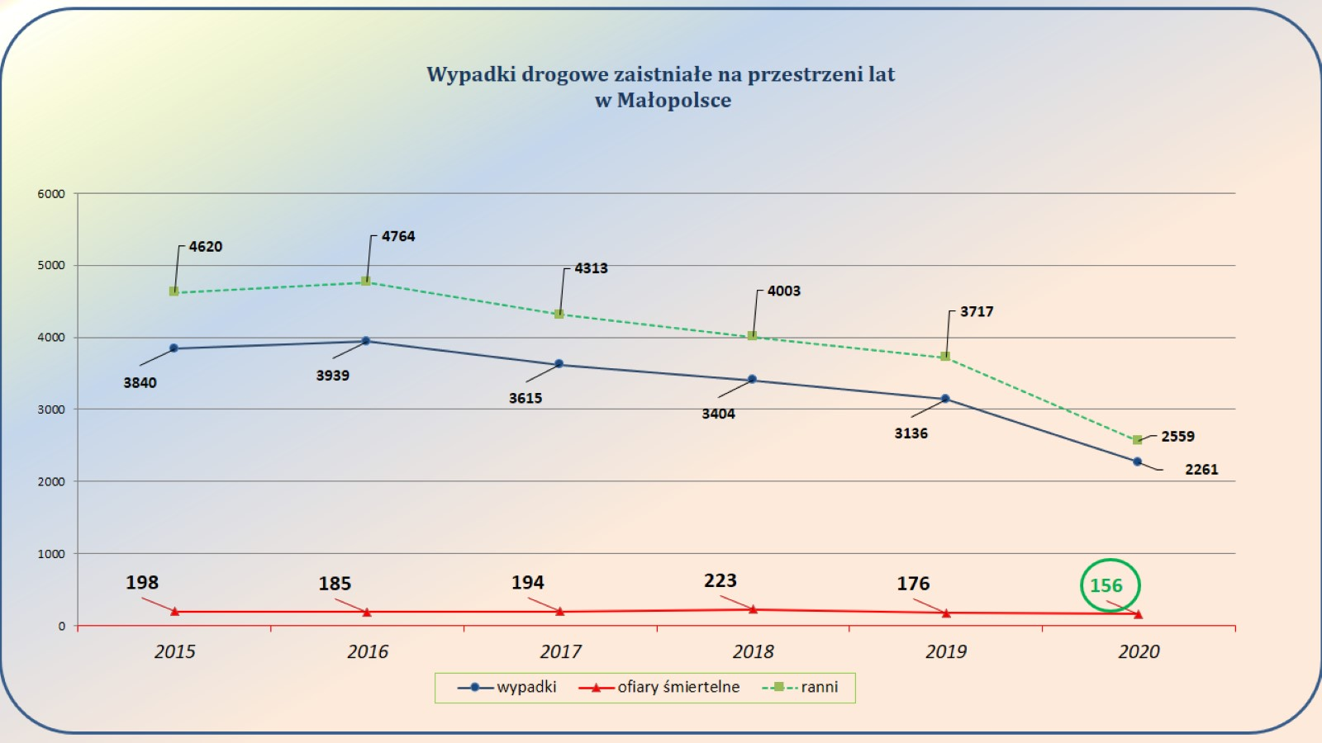

Number of road crashes of pedestrians in Malopolska

Crashes

Fatal victims

Victims

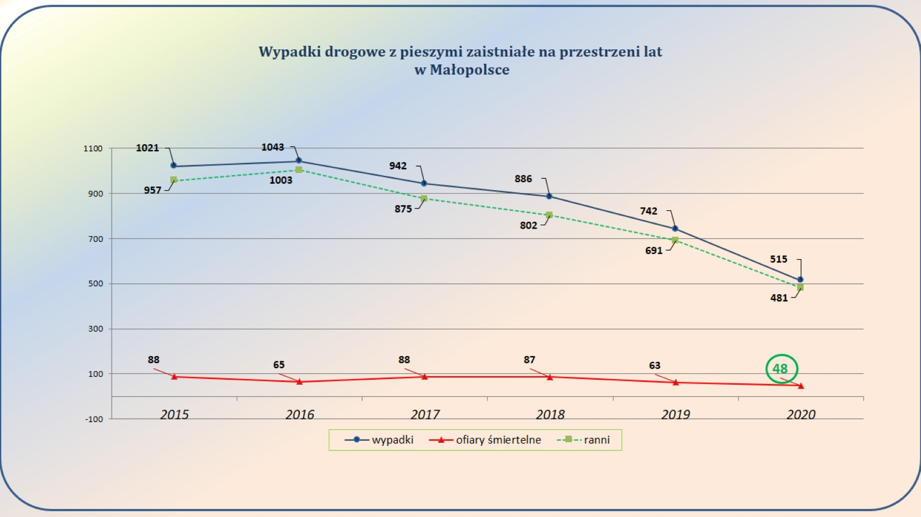

**2021: What’s next?**

**In 2021 the Council and its members continue:**

* Illumination of pedestrian crossings: 82 pedestrian crossings for provincial roads assigned for illumination , with possibility to increase them to the number of 118
* Enforcement of new law in Poland concerning pedestrians (valid since June 1st 2021): priority not only for those who are on the crossing, but also for those who enter the the crossing - regional strong pedestrian campaign of all members
* New economical support for psychological help for the Victims and the Families
* Continuation and enforcement of education programs aimed at pedestrians

Additional information

How does the project meet the Safe System Principles?

We accept that people make mistakes and that the body has limited physical ability. That is why we change the attitudes towards prevention and education. We also focus on change of infrastructure so that the pedestrians are safer and more visible. We strengthen the post-crash response. The Council joins over 30 organizations among others national, regional, non-profit organizations – all together from different perspectives as a shared responsibility.

How can the pilot project be used to scale road safety in the region/country?

The project has been applied in the region of Malopolska, part of it ( illumination project) has been applied after 2 years in whole country. The project could easily be implemented in other regions, as the safety of pedestrians is one of the main problems not only in Poland.

Who are the main actors of the project?

Regional Malopolska Road Safety Council (respond directly to Marshall of Malopolska) - the council includes 30 organizations www.brd.malopolska.pl

Malopolska Police

www.malopolska.policja.gov.pl

Regional Authorities of Malopolska.

www.malopolska.pl